Reel-to-Reel Inkjet Label Printer
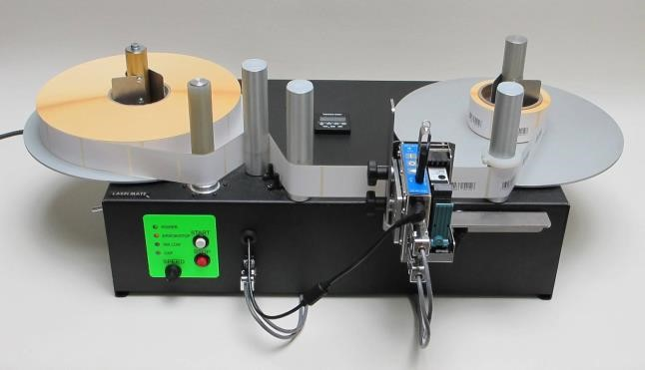
PACKAGE CONTENTS:

- Power Cord
- Print Head Assembly and Cable
- Preset Counter instructions

SPECIFICATIONS:
Max. Label Roll Weight: 6Kg.
Max. Label Roll Size: 300mm diameter
Speed: Min. 65cm/sec. – Max. 150cm/sec. for LS and 220cm/sec. for HS. Max. speeds specified with a
76mm take-up roll diameter.
Power Supply: 100-230V – 50-60 Hz. AC Input.

IMPORTANT INFORMATION:

- This product is a reel-to reel label printer with counter. It is only to be used to print (rewind/unwind) labels to of the recommended dimensions and weight in an indoor, dry environment.
- The machine has to be unplugged before any manipulation.
- The machine is to be used on a flat surface.
- Do not leave the power cable in a passageway.
- The ambient light of the working area needs to be sufficient to avoid any risk.
- The P-300 can be used in ambient temperatures of +2°C to 40°C.

COUNTER:
To use the preset function, input the desired number of labels with the Push Buttons on the Counter. If you do not use preset, set the value to “0”.
When the preset number of labels is reached, the P-300 will stop. Pressing the “Reset” on the Counter will reset the count to zero so the P-300 can be started again. A duplicate Reset Switch is located on the left side of the unit.

FRONT CONTROL PANEL AND HEAD CONNECTOR:
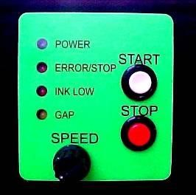
POWER (GREEN): Indicates power is applied to the unit. The ON-OFF Power Switch is on the rear of the Unit.

ERROR / STOP (RED): Indicates that either the unit is in STOP mode or one of the three Error Conditions has occurred:
  - The unit is Out Of Paper.
  - The counter has reached the Pre-Set Value.
  - There is a Print Head Error condition. e.g.: No more ink (condition valid only if the Print Head supplies this signal).
INK LOW (RED): Indicates that the Print Head has sent an Ink-Low Signal.

GAP (YELLOW): Flashes when Unit is running, indicating proper detection of the Gap between successive Labels.

START BUTTON (WHITE): Start printing if no Error Condition is present.

STOP BUTTON (RED): Holding down this button will stop the machine when the next gap passes in front of the photocell.

SPEED CONTROL: Varies the speed from zero to maximum.

LEFT SIDE CONTROL PANEL:

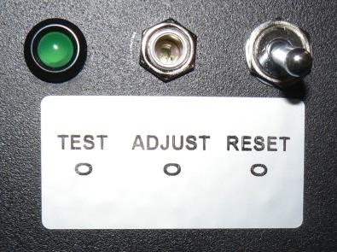
RESET: The new left-side control panel has three items. The toggle switch (reset) is a momentary closing switch, that has the same function as the reset button on the counter but is more convenient for the operator.
ADJUST: Potentiometer.
TEST: Green LED

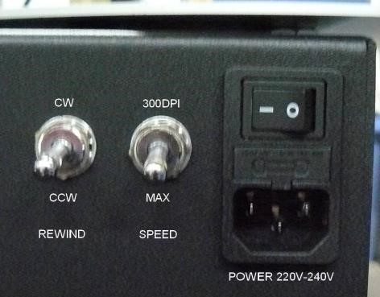
RE
AR PANEL:

DO NOT CHANGE DIRECTION WHILE THE MACHINE IS RUNNING. THIS COULD PERMANENTLY DAMAGE THE MACHINE.

The speed switch allows limiting the speed to 125cm/sec. That will allow printing a complete 30cm roll at 300DPI, with the front speed control set at maximum. If the roll is less than 22cm in diameter (76mm core), the maximum speed setting can be used, even for printing in 300DPI.

The rewind control allows to wide-in or wind-out.

ADJUSTING THE LABEL DETECTOR PHOTOCELL:

The label detector photocell has been adjusted at the factory (potentiometer fully CCW). Your labels might require adjustment of the photocell.

Load a roll of labels on the machine and position the backing paper in front of the photocell. Make sure that the labels are tensioned when doing the test. The LED should light on. If not, rotate the potentiometer till LED goes on
“green”. Now put a label in front of the photocell, the LED should turn off.

MAINTENANCE:
Your P-300 requires no maintenance but keep it dust-free.
WARRANTY:
Product Limited Warranty
All Labelmate Products are warranted to the original end-user customer to be free from defects in materials and workmanship. If it is determined by Labelmate that a product has failed under the terms of this warranty, the product will be repaired or replaced at no charge to the customer. Labelmate reserves all rights to determination of coverage and liability under this warranty. The warranty period for all new Labelmate products is outlined below:

Warranty Period | Products Covered
2 years | Label Rewinders  Label Unwinders
2 years | Label Counters (mechanical parts only)  Label Slitters (mechanical parts only)  Label Dispensers  Printer Mechanisms
1 year | Power Supply Modules  Counter modules  Encoders.

